**Lab Session 5**

**Ex A:**

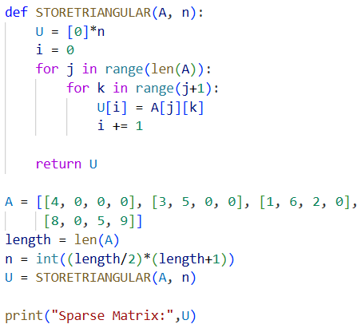**CODE**

**OUTPUT**

**Ex D:**

**CODE**

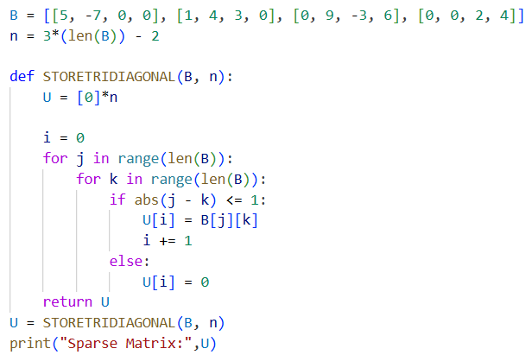

**OUTPUT**



**Ex E:**

**CODE**

**OUTPUT**



**Ex F:**

**CODE**

**OUTPUT**

